Appstream

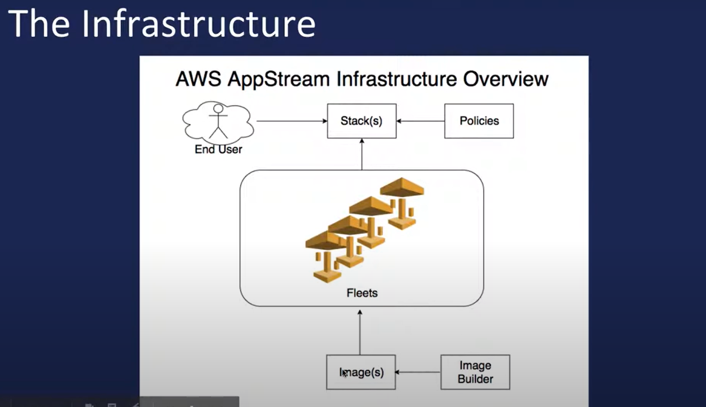

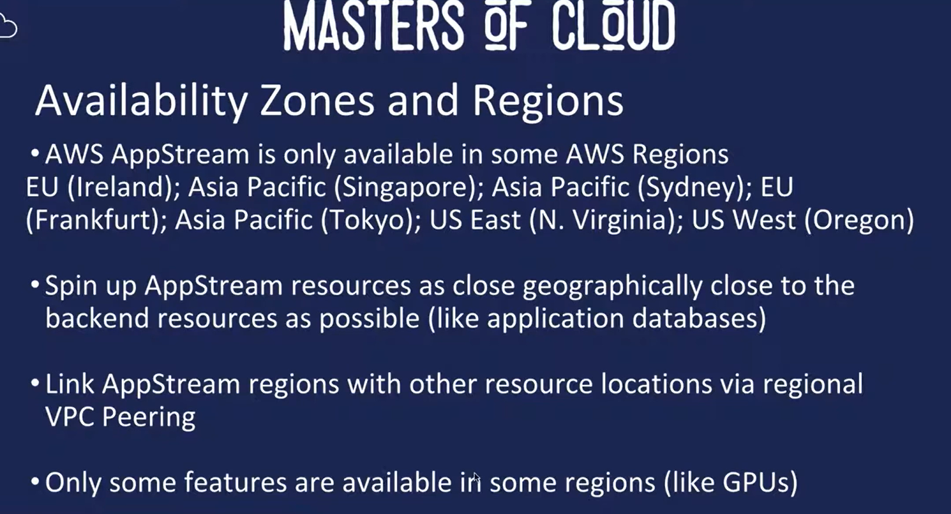

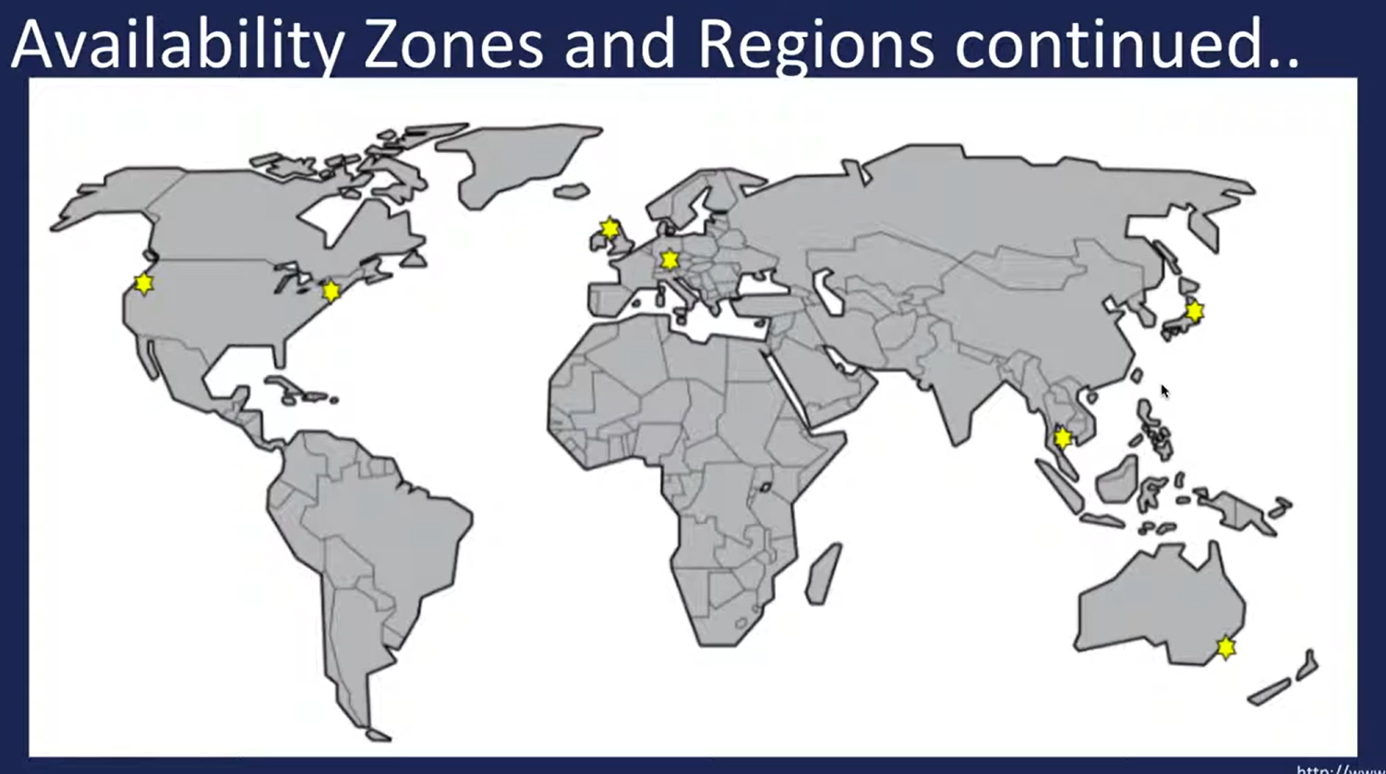

APPSTREAM_FLLET_IAM_ROLE_ARN=arn:aws:iam::883660979569:role/image_builder_viewer_role

<https://us-east-1.console.aws.amazon.com/iam/home?region=eu-west-1#/roles/details/image_builder_viewer_role?section=permissions>

* **Principle of least privilege**
* **Aws IAM Service**
* **IAM Users, Groups & Roles**
* **IAM Policies**
* **AWS Access Modes**
* **Creating IAM User with Programmatic Access**
* **Install and Configure AWS CLI**

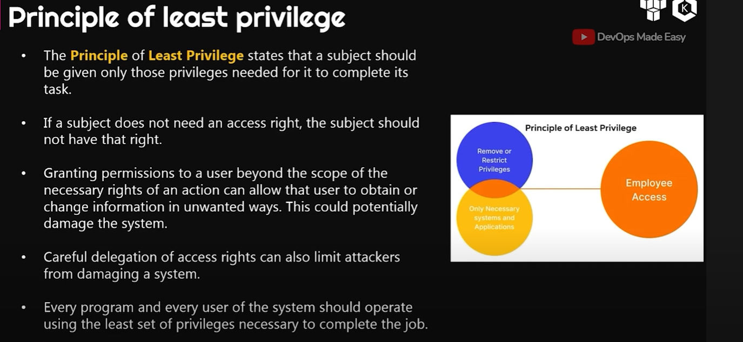

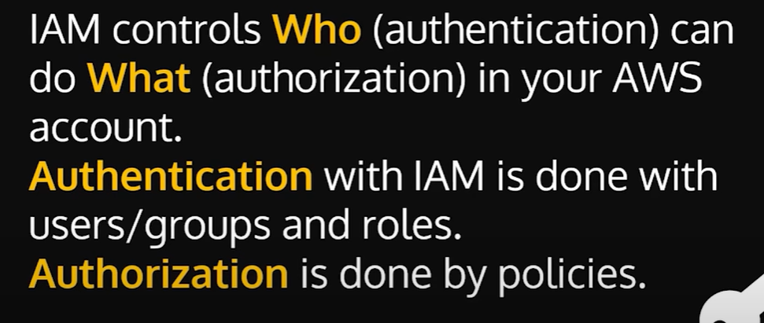

WHO : Authentication : users/groups and roles

WHAT : Authorization : policies

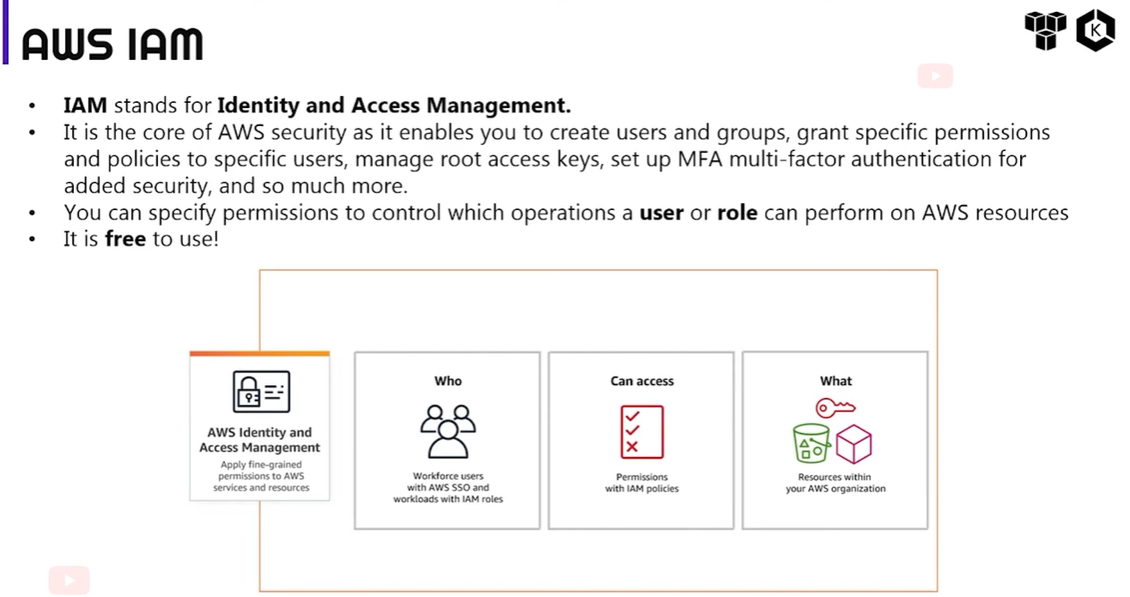

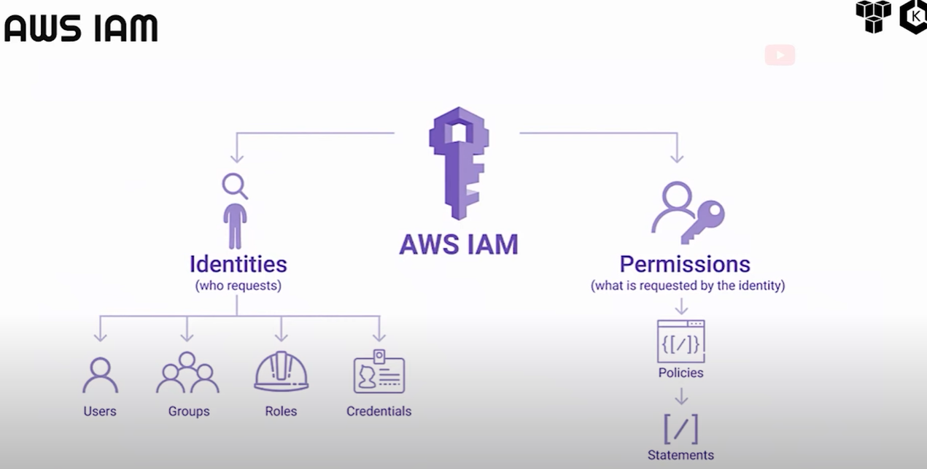

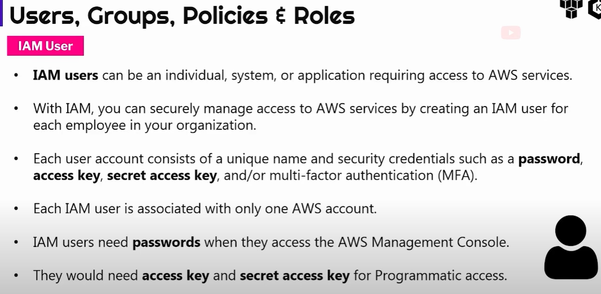

Users : can be an individual, system, or application requiring access to AWS services.

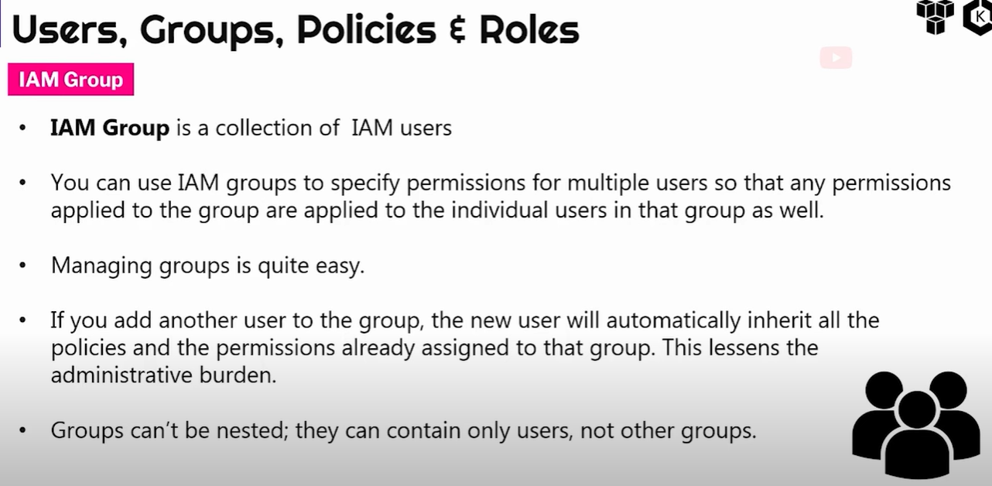

IAM Groups is a collection of IAM users.

A user that is a part of a group inherits automatically all permissions attached to the group.

Groups can’t be nested !!!

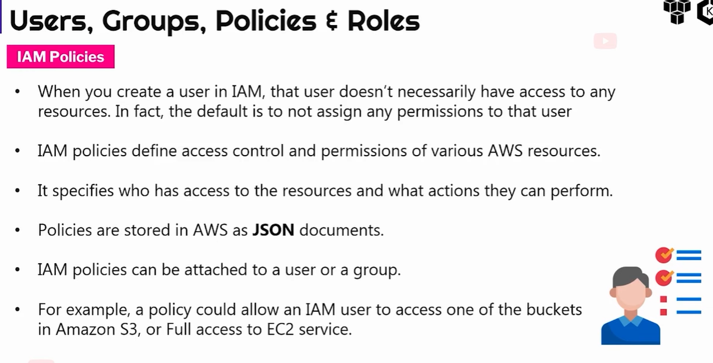

Policies are simply the permission attached to an IAM user/group or role !

IAM Policies define access control and permissions of various AWS resources !

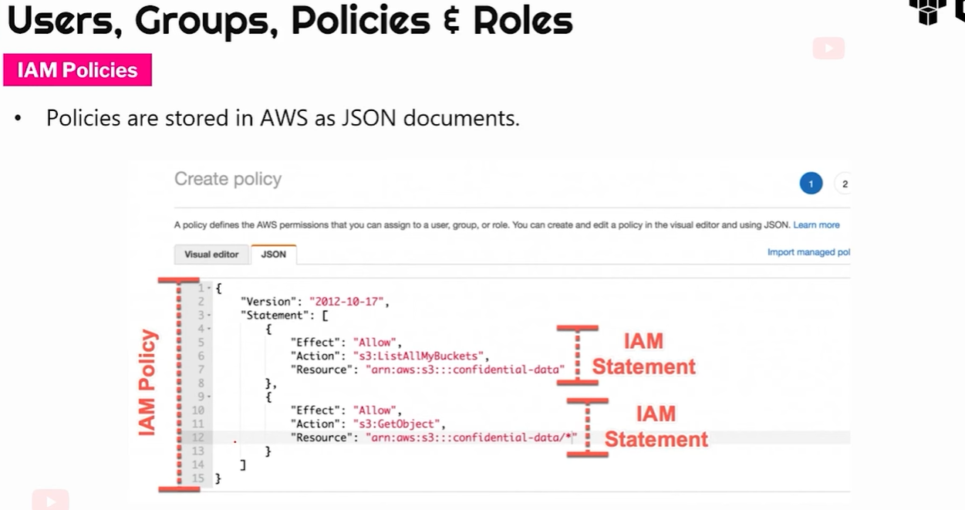

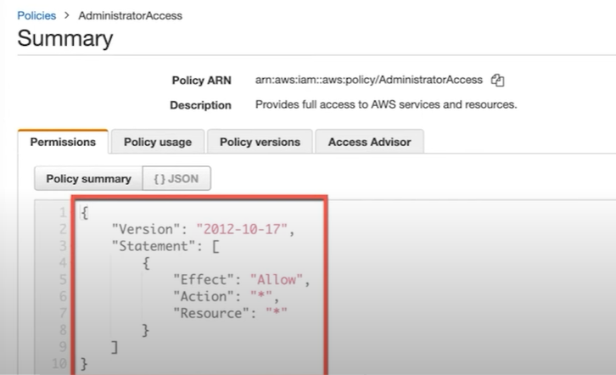

Policies can be attached to roles (AdministratorAccess role in the example above)

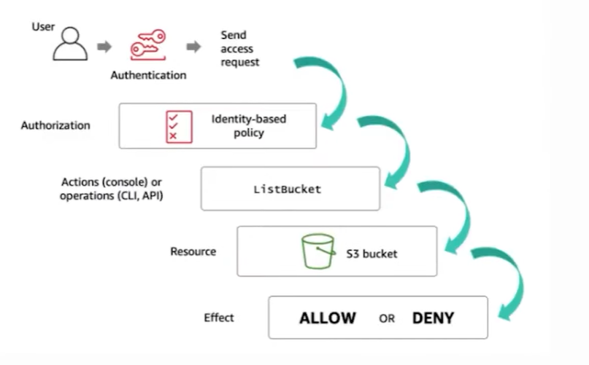

IAM ROLES

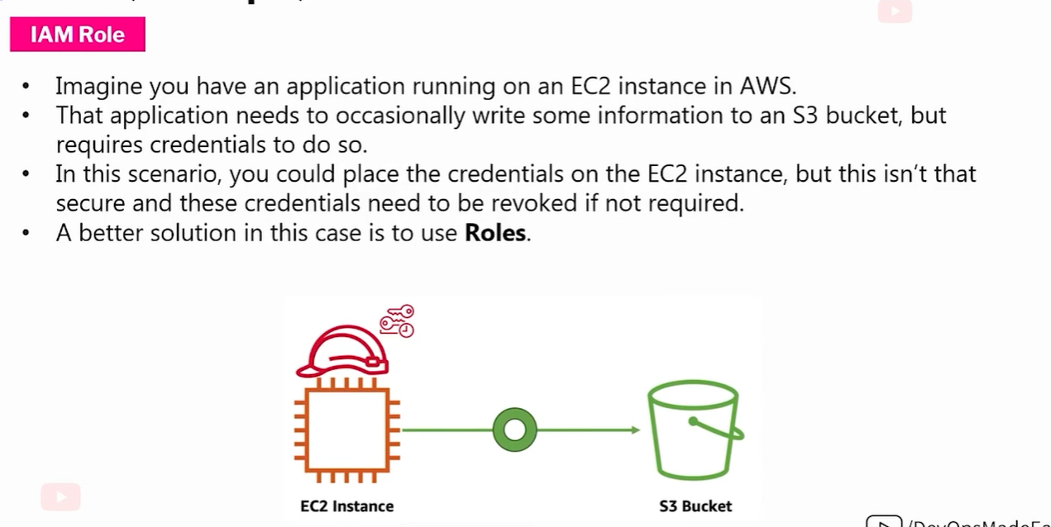

Difference between IAM user AND IAM role

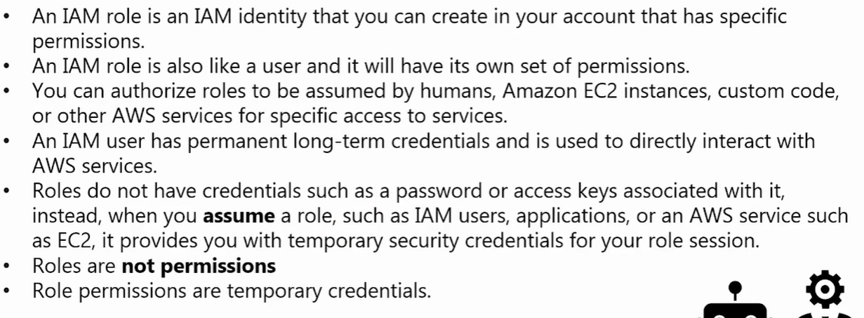

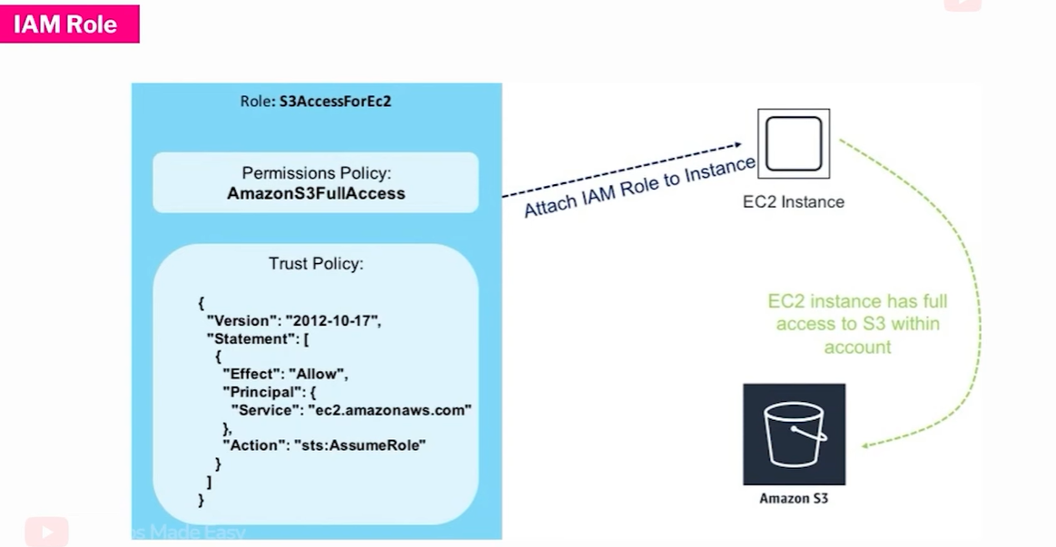

AWS ACCESS TYPES /

